



**6 week programme of** **Food Preparation and Budgeting skills**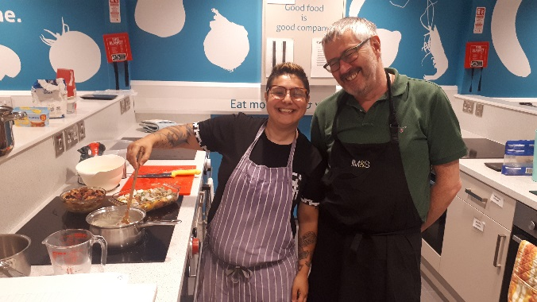

Our cooking programme supports people to make healthier food choices, develop and increase skill and confidence in: preparing and cooking meals from scratch; and shopping with a limited food budget.

The Food Preparation and Budgeting course consists of 6 x 3 hour classes with participants attending on the same day each week for 6 weeks, building up skills and confidence week by week. It provides a structured delivery to increase practical skills and confidence to allow individuals to live more independently.

**Programme Delivery –core outcomes covered:**

•         Following a recipe, preparing and cooking 2 dishes at each class and sitting down and eating the meal at the end;

•         Understanding basic food hygiene and safety;

•         Understanding foods which contribute to a healthy lifestyle;

•         Recognising signs of spoilage in food and understanding use by/best before dates;

•         Using kitchen equipment safely;

•         Demonstrating food preparation and cooking techniques;

•         Menu planning and cooking on a budget;

•         Using left overs;

•         Graduation with certificate, goody bag and Cyrenians recipe booklet

Upon successful completion of the course and all of its elements, participants can additionally gain an accredited REHIS certificate in Elementary Cooking Skills <http://www.rehis.com/sites/default/files/elementary_cooking_skills_-syllabus.pdf>.

This certificate can be used for employability purposes.

**Programme Days**

Mondays – 11am – 2pm

Tuesdays –       11am – 2pm

Wednesdays – 11am – 2pm

Thursday 2.30pm – 5.30pm

**Is your client eligible?**

The programme is open to individuals aged 16 and above who are resident in the City of Edinburgh Council area and are living independently or are working towards living independently.

If you are unsure whether or not your client is suitable for referral, please get in touch to discuss.

**How to Refer Clients**

**It is** **important that before you refer your client, that they are committed to start and complete the programme over the set 6 weeks**.

Please complete the attached referral form and post or email Kaz or Emma ([foodeducation@cyrenians.scot](mailto:foodeducation@cyrenians.scot))

On receipt of your referral, we will contact you to arrange a suitable time for you and your client to visit the Jane Street kitchen and have a more detailed chat about the programme and complete an enrolment form. This will only take about 20-30 minutes.

**Cyrenians**  
Flavour and Haver Cook School

64 – 66 Jane Street

Edinburgh EH6 5HG

Tel: 0131 554 3900 ext 3

[www.cyrenians.scot](http://www.cyrenians.scot)